1)

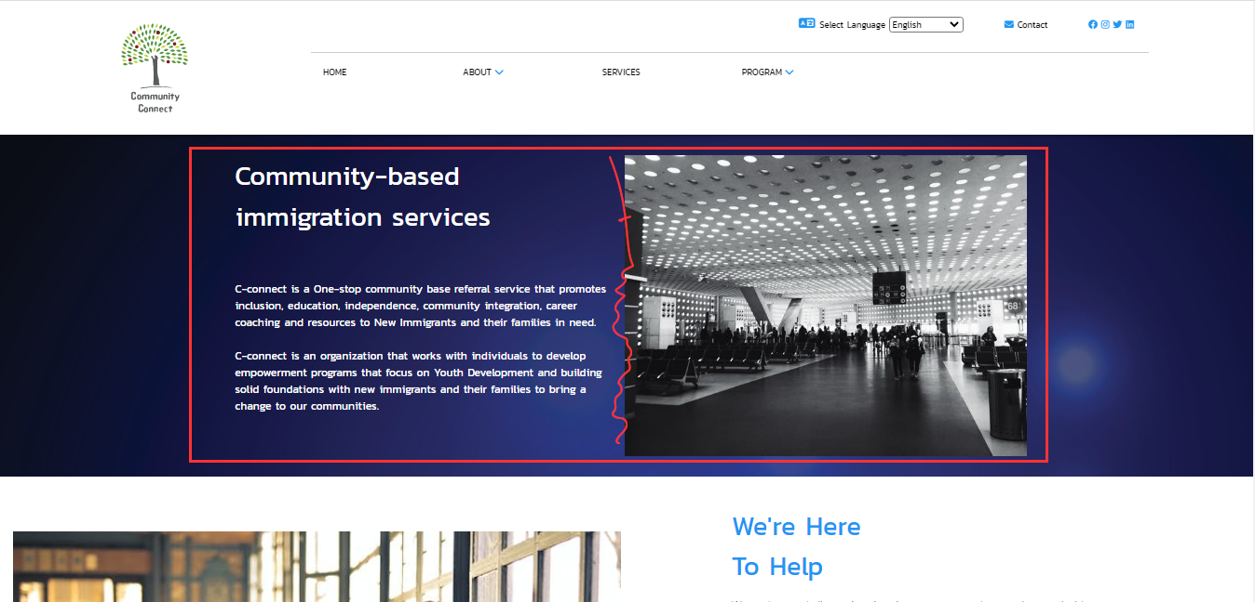

Highlighted in red: The image is meant to scroll alone to show the different scenes BUT the test beside it is also scrolling and that is meant to be static. It keeps on scrolling with the image and I can’t read it for more than 5 seconds because it won’t STAY STILL! It also induces a headache as I try to read it as it moves.

Please keep the text static while the image scrolls

1b)

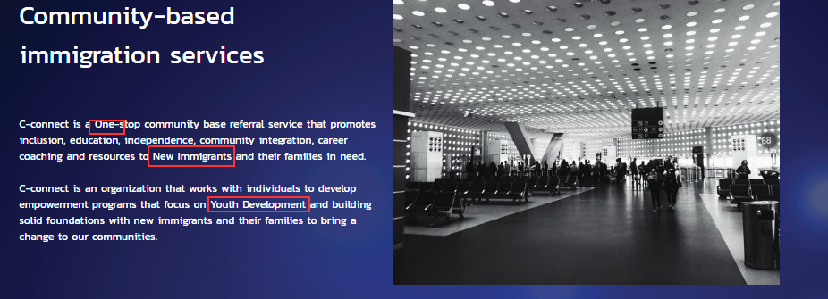

Uppercase letters are unnecessary. Please change to lower case unless client insists. Also change the 7th word on the first line from ‘base’ to ‘based’

2)

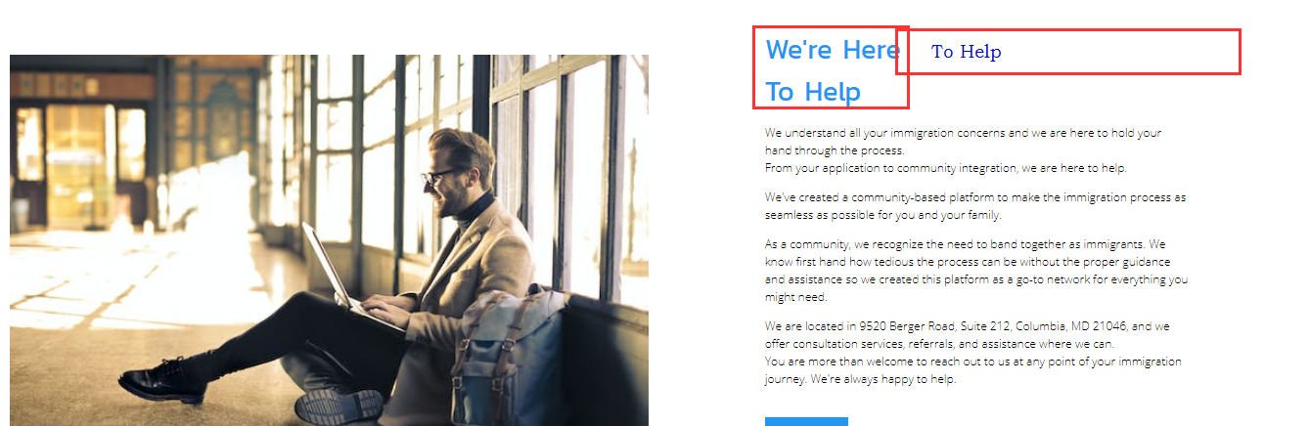

Please keep the highlighted test on the same horizontal line. Also change the 13th word on the 4th paragraph, from ‘of’ to ‘on’. It should be “At any point ON nor point OF.

3)

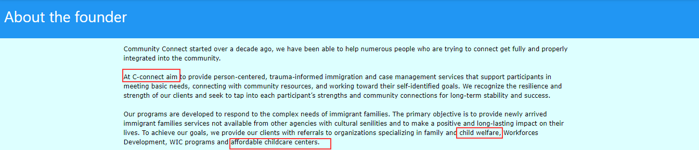

Typos: “At C-connect WE aim

Capitalize to “Child Welfare” and “Affordable Childcare Centers”

4)

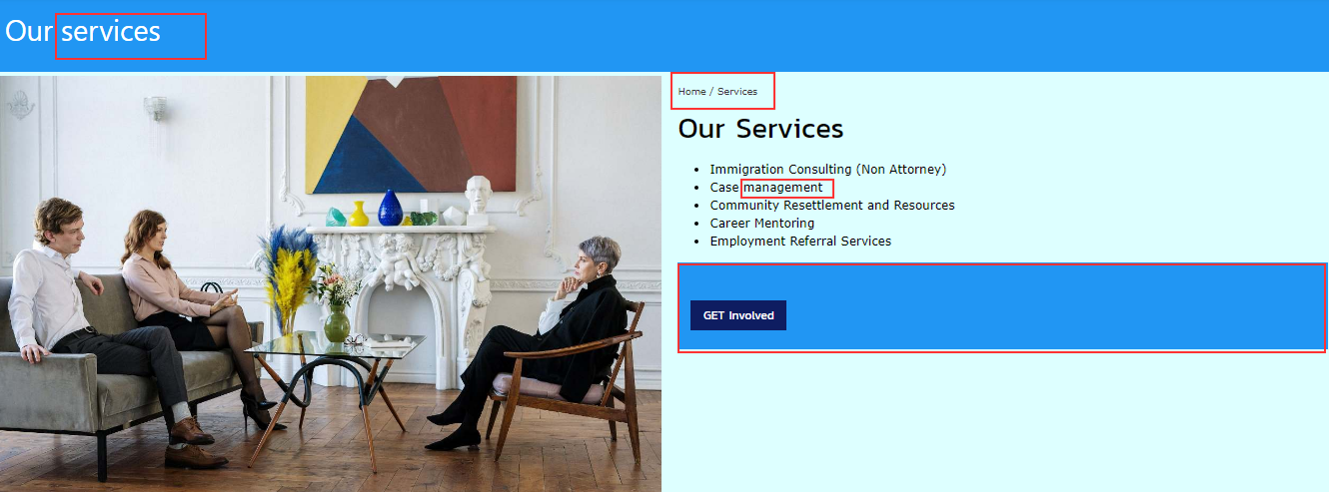

1. Capitalize: change “services” to “Services” AND “management’ to “management”
2. The blue rectangle around the “get involved” button seems pointless

5)

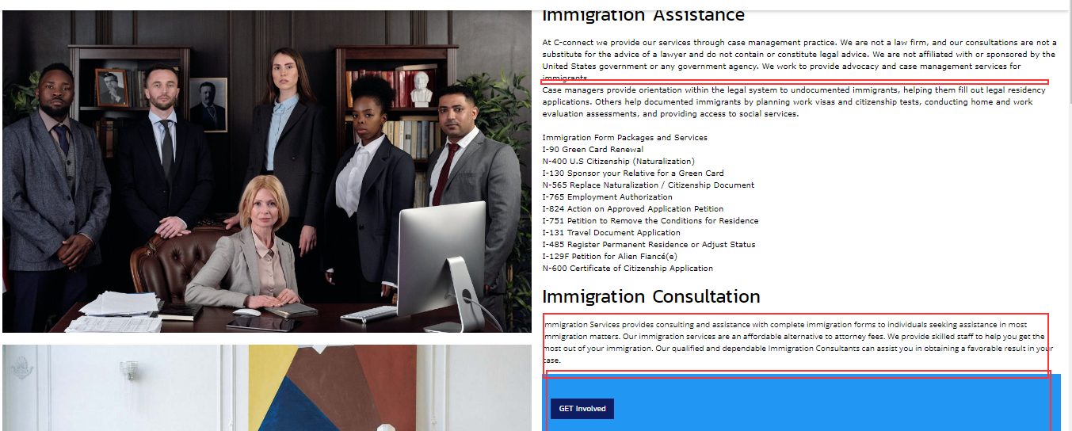

1. Add space between the first paragraph
2. Regularize font sizing under Immigration Consultation
3. Remove unnecessary blue rectangle around “get involved”

6)

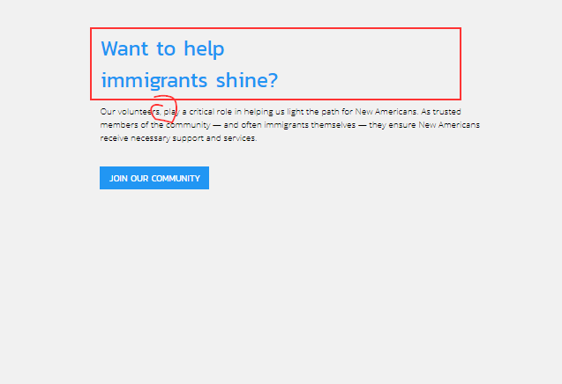

1. Keep text on a straight horizontal line
2. Remove the comma after volunteers

7)

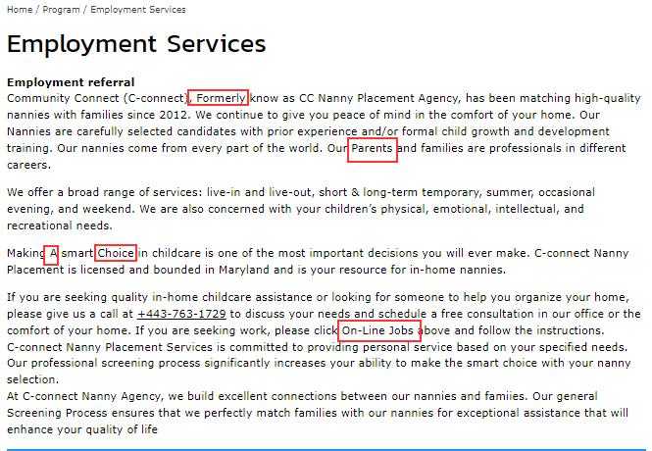

1. Remove capital letters from words highlighted.
2. Change “click On-Line Jobs” to “click on Line Jobs

Also where is the “Line Jobs” links above?